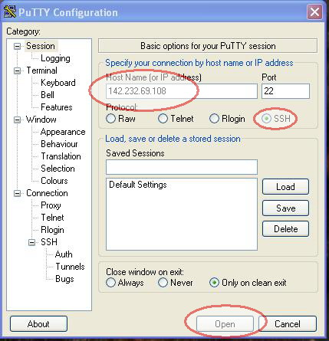

- Type the address obiwan.bcit.ca not 142.232.69.108 as in the example into the space provided.
- Make sure the SSH radio button is selected.
- Click the open button.

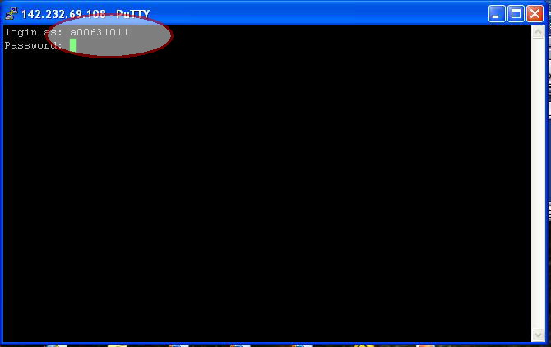

- Type in your complete BCIT Student ID making sure to use a lowercase 'a' instead of an uppercase 'A' (e.g. a00000000).
- Since you have changed the password in class last Saturday you will need to enter the new password. If you can't remember it then I can/will reset it for you.
- Enjoy!

P.S. That security alert is just saying that it wants to cache the signature of the server on your machine so you know that you are in fact connecting to the same machine that you thought you were. As long as port 22 is open for outgoing connections on your firewall at work you should be able to connect with no problem.

